**For coefficient of discharge**

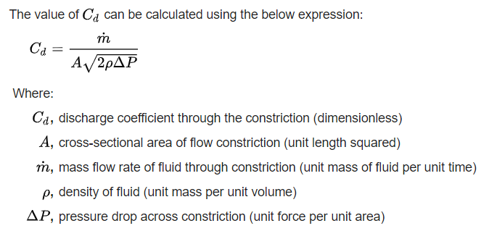

<https://physics.stackexchange.com/questions/419469/why-does-compressible-flow-never-choke-in-a-thin-plate-orifice>

This link states discusses that in orifice choking never happens.

<http://www.engsoft.co.kr/download_e/steam_flow_e.htm>

Static pressure and stagnation pressure relation

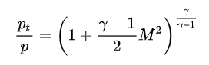

Static temperature and stagnation temperature

Relation of critical pressures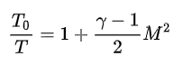

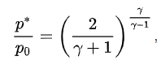P0 is total stagnation pressure upstream

But is P* or P critical measured static pressure for downstream

(Reference Wikipedia: <https://en.wikipedia.org/wiki/Choked_flow#cite_note-6>

choked flow usually occurs when the downstream static pressure drops to below 0.487 to 0.587 times the absolute pressure in stagnant upstream source vessel. Value calculated using the heat capacity ratio)

For orifice basic info and calculation

<https://en.wikipedia.org/wiki/Orifice_plate>

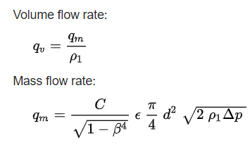

## Computation according to ISO 5167[[edit](https://en.wikipedia.org/w/index.php?title=Orifice_plate&action=edit&section=9)]

Flow rates through an orifice plate can be calculated without specifically calibrating the individual flowmeter so long as the construction and installation of the device complies with the stipulations of the relevant standard or handbook. The calculation takes account of the fluid and fluid conditions, the pipe size, the orifice size and the measured differential pressure; it also takes account of the [coefficient of discharge](https://en.wikipedia.org/wiki/Discharge_coefficient) of the orifice plate, which depends upon the orifice type and the positions of the pressure tappings. With local pressure tappings (corner, flange and D+D/2), sharp-edged orifices have coefficients around 0.6 to 0.63,[[14]](https://en.wikipedia.org/wiki/Orifice_plate#cite_note-ASME1971-14) while the coefficients for conical entrance plates are in the range 0.73 to 0.734 and for quarter-circle plates 0.77 to 0.85.[[2]](https://en.wikipedia.org/wiki/Orifice_plate#cite_note-Miller-2) The coefficients of sharp-edged orifices vary more with fluids and flow rates than the coefficients of conical-entrance and quarter-circle plates, especially at low flows and high viscosities.

Coefficient of discharge for sharp-edged orifice plates with corner, flange or D and D/2 tappings and no drain or vent hole (Reader-Harris/Gallagher equation):



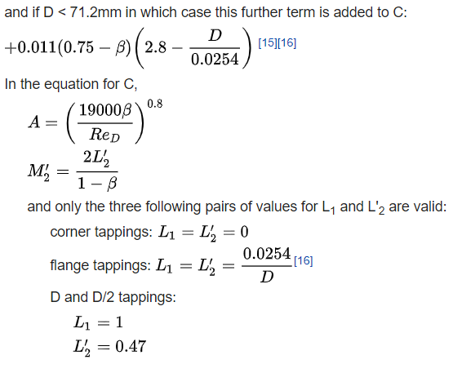

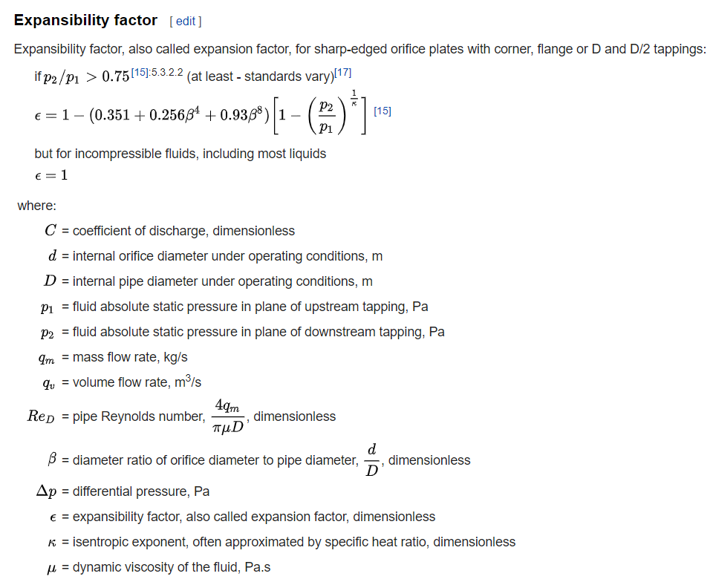

For coefficient of discharge calculation in other way, (Very important and useful)

<https://neutrium.net/fluid_flow/discharge-coefficient-for-nozzles-and-orifices/>

Some talk on changing temperature after orifice

<https://www.researchgate.net/post/How_I_can_calculate_the_temperature_after_a_stage_of_orifice_plate_in_which_we_drop_pressure_from_P1_to_P23>

**Notes on ISO 5167- Part 1 (not much useful)**

ISO 5167 (all parts) is applicable only to flow that remains subsonic throughout the measuring section and where the fluid can be considered as single-phase. It is not applicable to the measurement of pulsating flow.

β= dia(orifice or throat)/ internal dia. Of measuring pipe upstream of primary device

**Pipe Reynolds number**

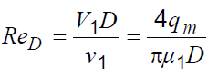

For Orifice

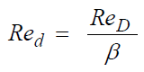

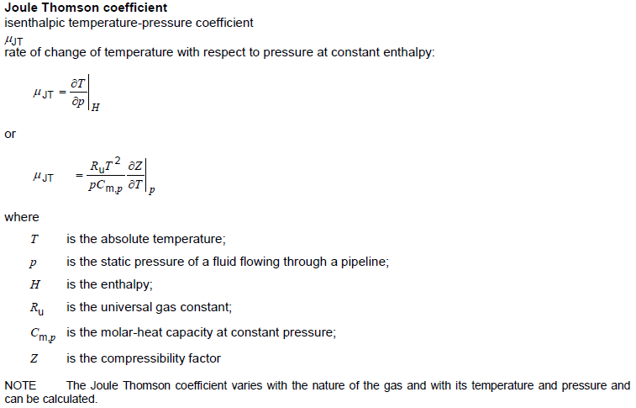

Mass flow rate

C:Coefficient of Discharge; ε Expansibility factor

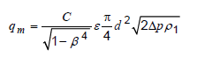 (1)

**Method of determination of the diameter ratio of the selected standard primary device**

In practice, when determining the diameter ratio of a primary element to be installed in a given pipeline, *C* and

ε used in Equation (1) are, in general, not known. Hence the following shall be selected a priori:

 the type of primary device to be used; and

 a flowrate and the corresponding value of the differential pressure.

The related values of *qm* and Δ*p* are then inserted in Equation (1), rewritten in the form

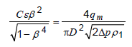

in which the diameter ratio of the selected primary device can be determined by iteration (Annexure A)

**Miscellaneous**

<https://web.archive.org/web/20150101190305/http://www.air-dispersion.com/feature2.html>

Gas leak models, good example values and calculation. Properties also available.